**ASSIGNMENT**

**Name:**Muhammad Bilal Haneef Qureshi

**Program:** BSSE(Evening)

**Section**: A

**Course**: ICS

**REVISION SHEET 1:**

1) Install Linux

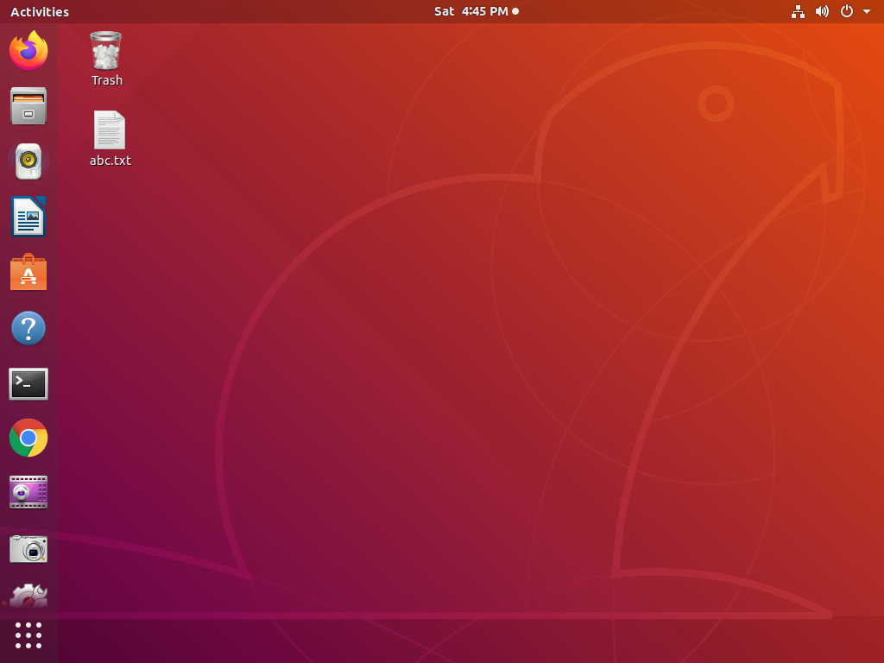

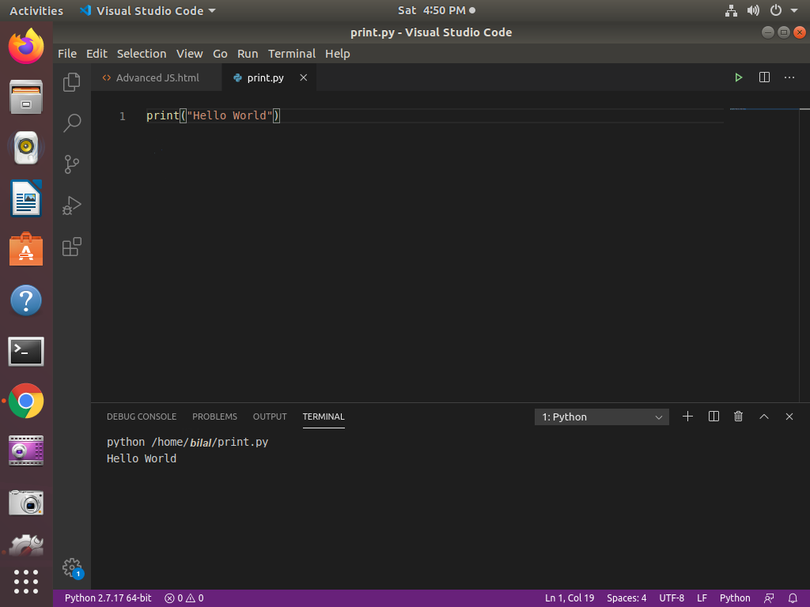2) Install python: use IDLE as IDE or any other of your choice.

3) Why combination of breadth-first + programming-first approaches?

* In breadth first approach we crack the given problem into small chunks.
* Breadth first approach include understanding the problem.
* Breadth first approach include writing algorithm of the problem.
* Breadth first approach include writing pseudo code of the problem.
* Breadth first approach also include the architecture of the given problem.
* In programming first approach we use the data that we have extracted from the given problem by Breadth-first approach.
* Programming first approach include the coding of given problem.
* Combination of **Breadth-first** and **Programming-first** approach provides effectiveness to any problem.
* It also provides smoothness to the whole process.

4) Why we are shifting from C# to python as first programming language?

Following are the reasons that why we are shifting from C# to Python.

* Syntax of python is very easy as compared to C#.
* Python is very fast when it comes to code deploying code.
* Python is a key programming language for Artificial Intelligence , Machine Learning and Data Science.
* Python has amazing libraries that ease programming at an extent.
* Python is Open-Source so it’s easy to use for commercial purposes.
* One of the key features of Python is that it provides readability as compared to C#.
* Python is Dynamic Typed Language, but C# is Static Typed Language, when it comes to dynamic languages, the development process is relatively fast and easy. Since C# is a static language, it includes a build/compile step, which some developers are not fond of.

5)Difference between Computer Science, Software Engineering, Information Technology.

|  |  |  |
| --- | --- | --- |
| Computer Science (CS) | Software Engineering (SE) | Information Technology (IT) |
| [Computer Science (CS)](https://cs.uwaterloo.ca/) focuses on understanding, designing, and developing programs and computers. | [Software Engineering (SE)](https://uwaterloo.ca/software-engineering/home) deals with building and maintaining software systems. | Information Technology, mainly study about how to make Information based technology such as website, information system, android application. |
| At its core, Computer Science concentrates on data, data transformation, and algorithms | It is more software-oriented and has a greater emphasis on large software applications than Computer Engineering. | IT education is fundamental for a computer science degree that later leads to job opportunities. |
| Advanced courses present specialized programming techniques and specific application domains | It is more applied than Computer Science, placing greater emphasis on the entire software development process, from idea to final product. | IT can be specialized in many ways, but CS graduates have opportunities immediately available to them that IT qualified workers don’t. |

6) Computer Science careers.

* Data Scientist.
* Machine Learning Expert.
* Data Analyst.
* Technical Developer.
* MERN Stack Developer.
* MEAN Stack Developer.
* Software Developer.
* Network Manager.
* Project Manager.
* Mobile Application Developer.
* System Analyst.